Nepal College of information Technology
Imado lalitpur
Assessment Exam Spring Semester 2007

Program : ELX/IT Semester: Spring
Time : 3hrs Year : 2007
Engineering Math-II

1 a) Find the equation of the plane through the intersection of the plane 2x+3y+10z=8 and 2x-3y+7z=2 and normal to the plane 3x-2y+4z=5 8
b) Find the equation of the plane containing
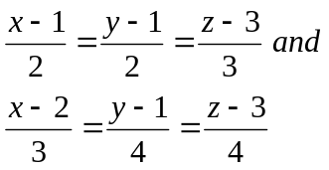 7
2. a) Sketch the region of integration and evaluate by interchanging the order of the double integral.
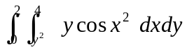 7
b) Find the volume of the solid whose base is bounded by y=4-x² and y=3x while top is bounded by z=x+4 8
3. a) Solve 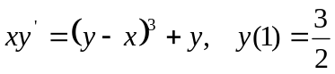 7
b) Solve 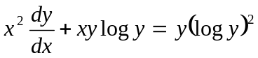 8
4. a) Solve: y"-3y' =e^{3x} - 12x 7

b) Solve: y" + 2y' = e^{-x} cosx 8

5. a) Solve: y" + 4y = 0 by power series method. 7

b) State and prove second shifting theorem of Laplace transform. Find Laplace transform of u_{a} (t) 6+2

6. a) Solve y" + w²y = =0, y(0) = 1 y' (0) =2 by using Laplace transformation. 7

b) Find f(t) if
i) 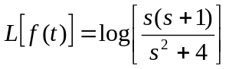
ii) 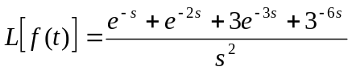 4+4
7. a) Find Laplace transform of t coswt 5*2
b) Find integrating of factor of 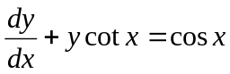
c) Evaluate 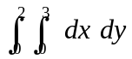
d) Solve 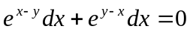

e) Find the distance from the point (3,4,5) to the point where the line 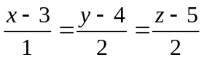 meets the plane x+y+z=2

